**Tetraethyl orthosilicate**

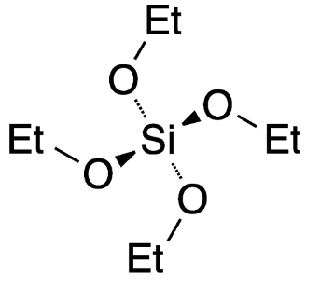 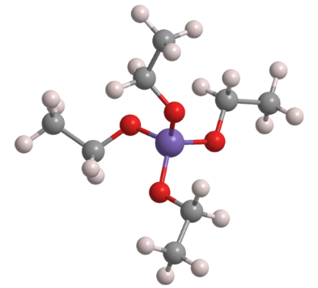

Tetraethyl orthosilicate (TEOS) is an ester of orthosilicic acid, which exists in small amounts in nature wherever silica is in contact with water. The ester is also known by several other names, including ethyl silicate (which is somewhat ambiguous), silicon tetraethoxide, and tetraethoxysilane.

In a landmark paper published in 1928, A. W. Dearing and E. Emmet Reid* at Johns Hopkins University (Baltimore) reported improved [syntheses of various alkyl orthosilicates](https://pubs.acs.org/doi/abs/10.1021/ja01398a031). TEOS was obtained in 70% yield by slowly adding silicon tetrachloride (SiCl4) to cold anhydrous ethanol, followed by removing byproduct hydrogen chloride with a stream of dry air. The reaction system must be rigorously free of water because even though TEOS is only slightly soluble in water, it hydrolyzes to form silica and ethanol. The reaction is the basis of modern TEOS production.

TEOS has multiple specialty uses, including stone hardening (which arrests the decay of structures and art objects), mortar and cement manufacture, and cross-linking silicone polymers. Its 2020 global market is [valued at US$245 million](https://www.marketwatch.com/press-release/global-tetraethyl-orthosilicate-market-share-and-size-2020-global-growth-new-updates-trends-industry-expansion-demand-by-regions-opportunities-showing-impressive-growth-by-2026-2020-08-28) for an estimated production of ≈120,000 t.